# Session 34: Angular Development Deep Dive

**Session 34: Angular Development Deep Dive 1**

Testing in Angular 1

Deployment and Optimization 2

**E2E Log 3**

Cyprus Testing 3

Successful Deploy to Netlify 4

Live Site URL: 4

GitHub Repos: 5

This session covers key aspects of Angular development, including UI components, testing methodologies, deployment strategies, and performance optimization.-----Angular Material & UI Components

Angular Material, built and maintained by the Angular team, adheres to Google's Material Design principles. It offers a comprehensive suite of responsive, accessible, and themeable UI components.

**Benefits:**

* Speeds up UI development with consistent styling.
* Mobile-friendly out-of-the-box.

## Testing in Angular

Testing is crucial for ensuring application quality and maintaining developer confidence.

**Importance of Testing:**

* Ensures features function as expected.
* Catches bugs early in the development cycle.
* Supports refactoring and continuous integration/continuous delivery (CI/CD) pipelines.
* Builds user confidence in the application.

**Types of Testing:**

* **Unit Testing:** Focuses on testing individual components or services in isolation.
* **End-to-End (E2E) Testing:** Simulates real user interactions across the entire application.

**Unit Testing Tools & Practices:**

* **Tools:** Jasmine (testing framework) and Karma (test runner). Both are included by default with the Angular CLI.
* **File Naming:** Test files are auto-generated with a `.spec.ts` extension.
* **Running Tests:** Use the `ng test` command, which launches the Karma test runner in a browser for fast feedback during development.

**Jasmine Basics:**

* `describe()`: Defines a test suite (a group of related tests).
* `it()`: Represents a single test or "spec" and describes an expected behavior.
* `expect()`: Used to define an assertion or expectation for the test.
* `beforeEach()`: A hook that runs before each test within a suite.
* `spyOn()`: Used to track and mock function calls.

**E2E Testing Tools & Practices:**

* **Cypress:** A modern, widely used E2E testing tool that allows you to observe the application being tested in a browser.
  + *Note: Cypress testing for this session was successful in Edge, but not Chrome.*
* **Protractor (Legacy):**
  + An older, Angular-specific E2E tool.
  + Utilizes WebDriver (Selenium-based).
  + Currently being deprecated in favor of Cypress and Playwright.
* 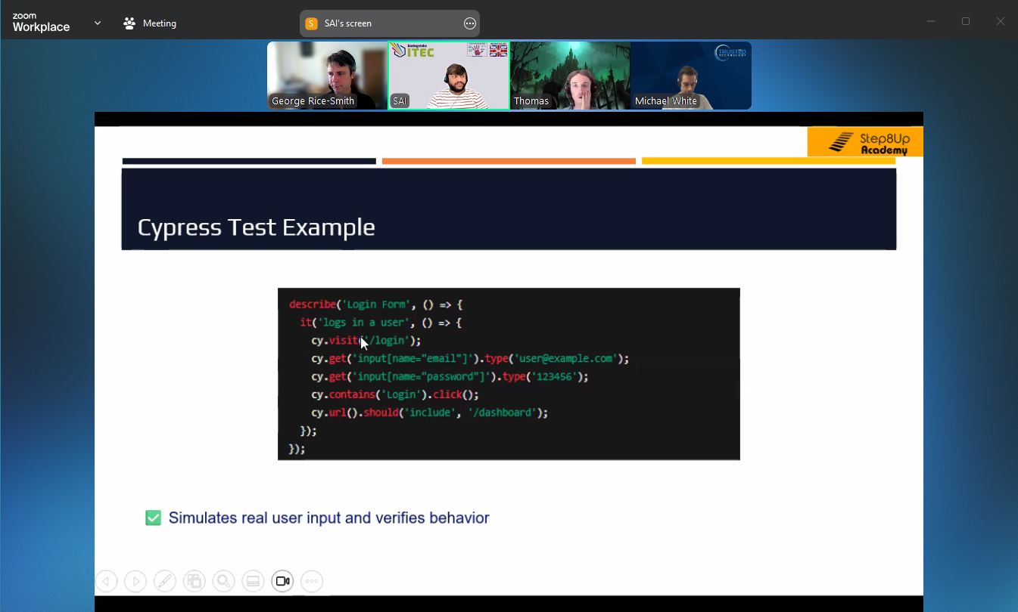

**Testing Best Practices:**

* Write one `it()` block per distinct behavior.
* Avoid testing private methods as they are internal implementation details.
* Use `spyOn()` to mock services for isolated testing.

## Deployment and Optimization

**Deployment Optimizations:**

* **AOT (Ahead-of-Time) Compilation:** Converts Angular templates to efficient JavaScript before the browser loads, leading to faster application loading times.
* **Minification and Bundling:** Removes unnecessary code, whitespace, and comments, and combines files to reduce application size.
* **Tree-shaking:** Eliminates unused code ("deadweight") from the final bundle.
* **Lazy Loading:** Breaks the application into smaller chunks, loading only what's needed for the initial screen, improving perceived performance.

**Deployment Output:**

* The optimized output is generated in the `/dist` folder, containing static files ready for deployment.

**Common Hosting Platforms:**

* Firebase Hosting
* Netlify / Vercel
* AWS S3 + CloudFront
* GitHub Pages
* Custom servers (e.g., Node.js, Nginx)

**Performance and Optimization Tips:**

* Implement lazy loading for modules.
* Utilize preloading strategies for anticipated routes.
* Compress images and other assets.
* Use `trackBy` in `*ngFor` directives to optimize list rendering.
* Minimize the use of third-party scripts.

## E2E Log

### Cyprus Testing

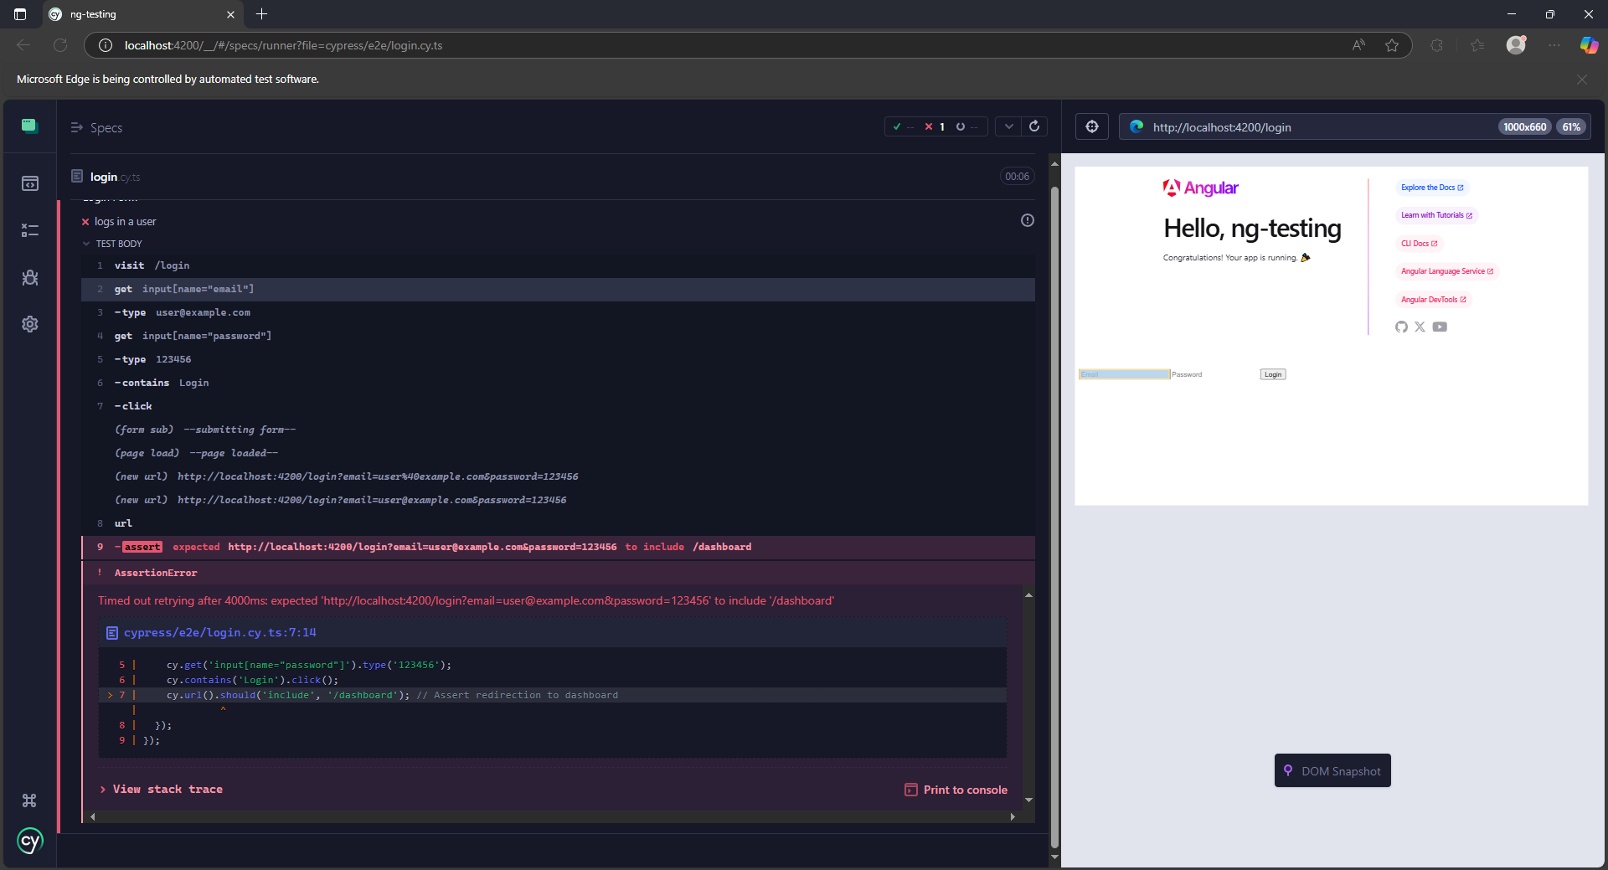

Successful logs:

Note this only worked in Edge, not Chrome

# 

## Successful Deploy to Netlify

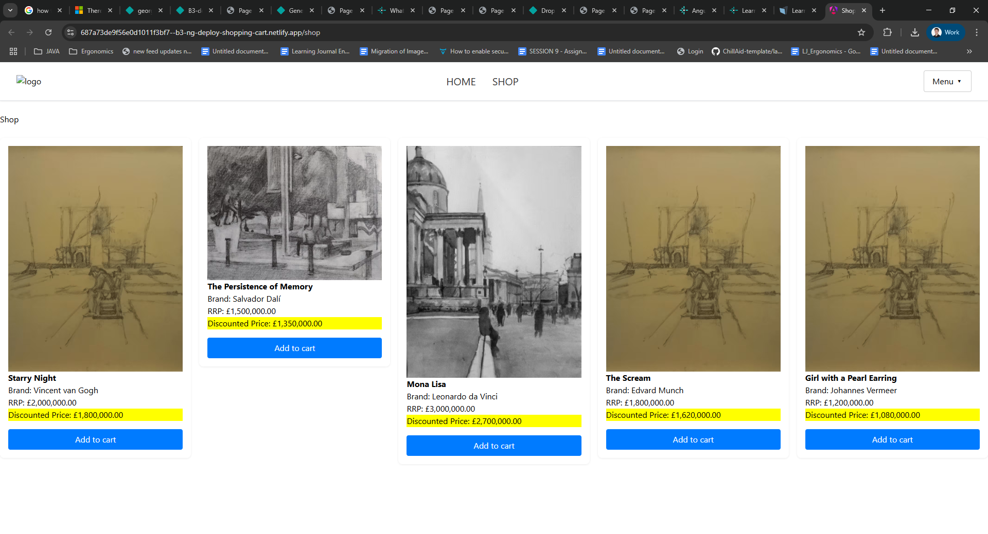

## Live Site URL:

<https://687a73de9f56e0d1011f3bf7--b3-ng-deploy-shopping-cart.netlify.app/shop>

## GitHub Repos:

<https://github.com/grs-se/B3-week-34>